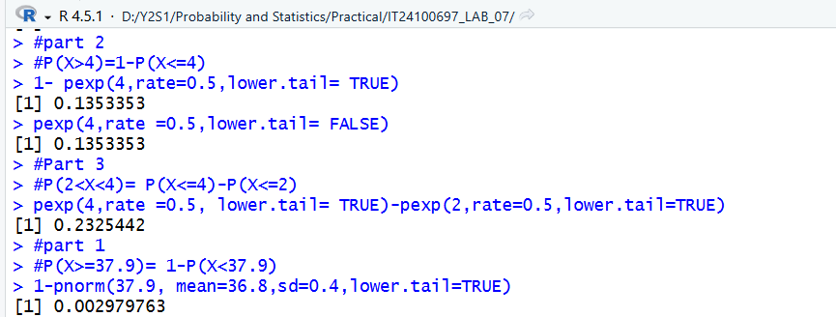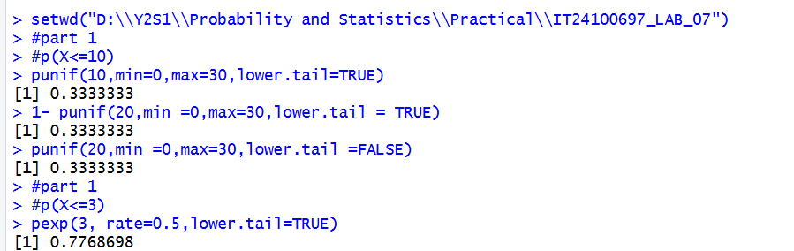

IT24100697 – Kamsha S

PS LAB SHEET -07

